**Progression Document for WebVR Project:**

Alex Dovey = Orange  
Edward Thornton = Red  
Mitch Rycroft = Blue  
Two People = Purple  
Everyone = Green

Initial thoughts for the VR experience:  
To begin with, we decided to continue creating and developing our own individual projects that we had been learning with, but add a menu to allow players to see all of our creations. This meant that nobody would lose any work effort that they had put in, and there was diversity in what we would be able to present.

After some careful thought, we decided that this idea would not be best suited for this project because we were put into groups for a reason, not to work on our own thing and create a weak link between them at the end.  
As a result of this, we decided to create one scene that we all contributed to. A few rough ideas passed until we decided that we would make a spaceship room that told a story. What I mean by this is that there has clearly been something that happened in the room and the outcome has left clear signs as to what.   
We decided upon a spaceship room simply because it seemed more interesting and played with the immersion aspect that we were challenged with. People tend to be more interested and immersed in something they have not seen before.  
[Alex Dovey & Edward Thornton]

Another idea that we had was to have the player as a robot that was strapped to a chair. This robot (the player) would have to answer questions, like an interrogation situation. For example, some of the questions and tasks would be to answer yes or no by clicking / looking at the respective answer on a screen, or maybe moving the camera / hands to create some resulting action.  
We decided against this because of the time constraints and the resources we will be viewing the scene on. We do not have access to the controllers for VR at this point in time, and do not have the knowledge to code complex algorithms such as the ones described.

From this, we decided to begin the scene by creating the entire room in 3Ds Max, allowing more freedom of placement, sizing and intricacy of the scene. This also means that we are able to texture the scene before it is in the code.

The modelling:

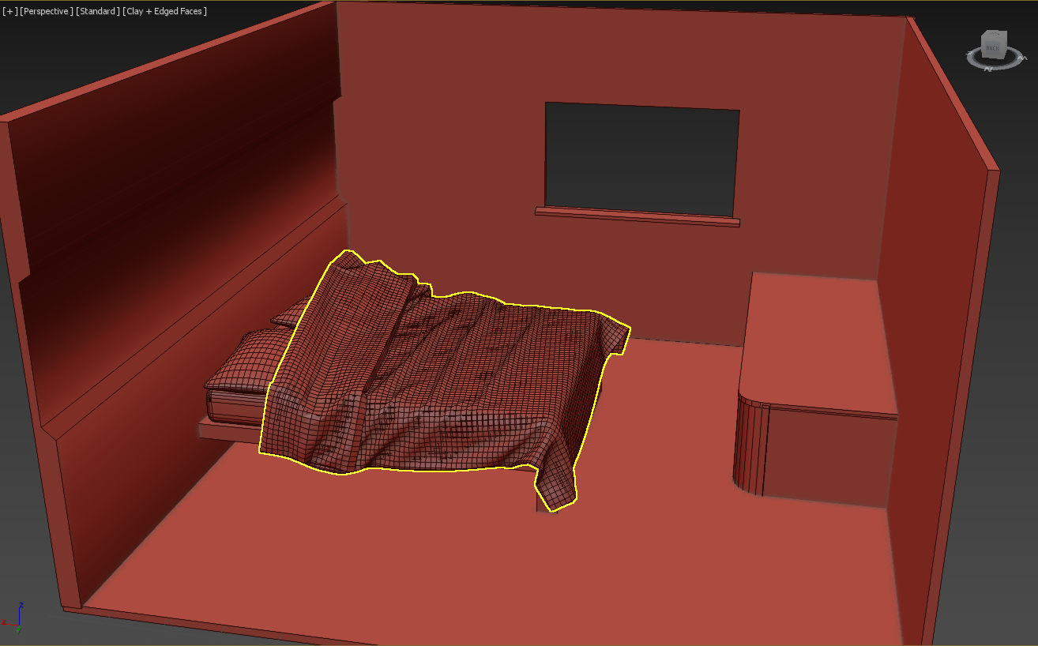This is the first image that was shown to Mitch, who is doing the sound and some of the texturing for the scene.

From this, we decided that maybe making this scene a lower end motel in space would be more interesting to look at. What we mean by this is that there will be visible pipes coming from the walls, dirty wall textures, steam and water sounds that are flowing through the pipes, neighbouring rooms, etc.

The above image is the final design that we have chosen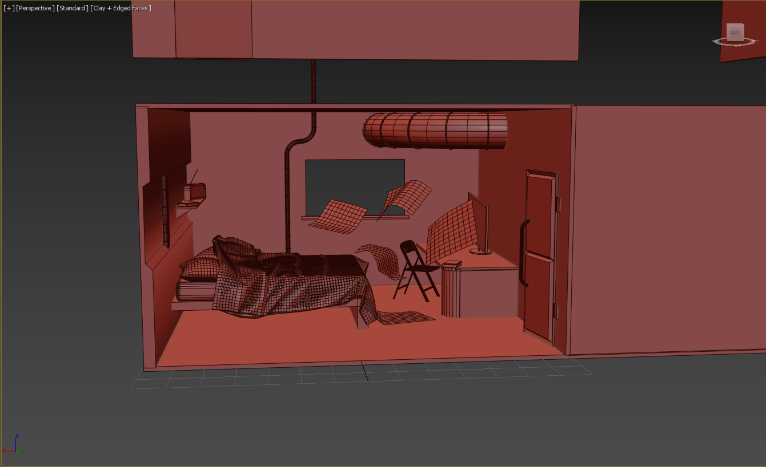 to have as part of our VR immersive experience.  
We plan to add in the textures using this program (3Ds Max) and using the .mtl file that is provided.

Implementing model into code:

Now that the model is finished, the plan was to attempt to load it within the website through code.  
This did not work out as we had hoped. It seems that the model has too much for the webpage to load, so it did not show at all.

Our next idea was to try and load individual segments of the room, and stop once they no longer worked, however, this would have taken far too much time and would have resulted in a bare looking room.

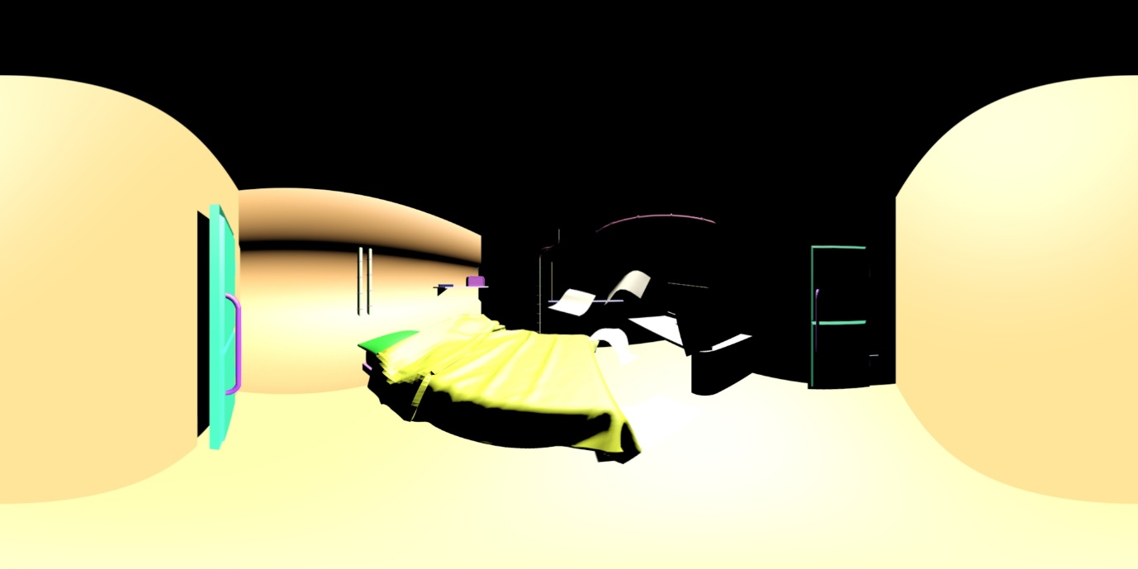Finally, we looked into creating a panoramic image to place onto the skybox.

This image above shows the 360-degree image that we placed onto the skybox as a tester, which worked well for what we are going for.

The plan was to add the textures after the tester and create another panoramic image to try once they all looked fitting. [Mitch Rycroft & Edward Thornton]

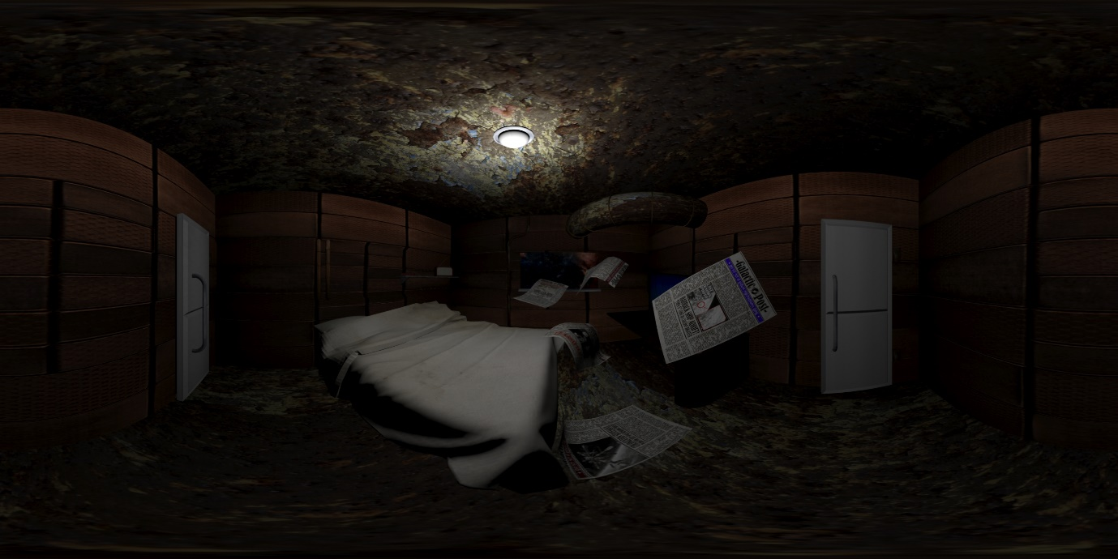

This is the final version of the panoramic with textures and correct lighting. [Mitch Rycroft & Edward Thornton]

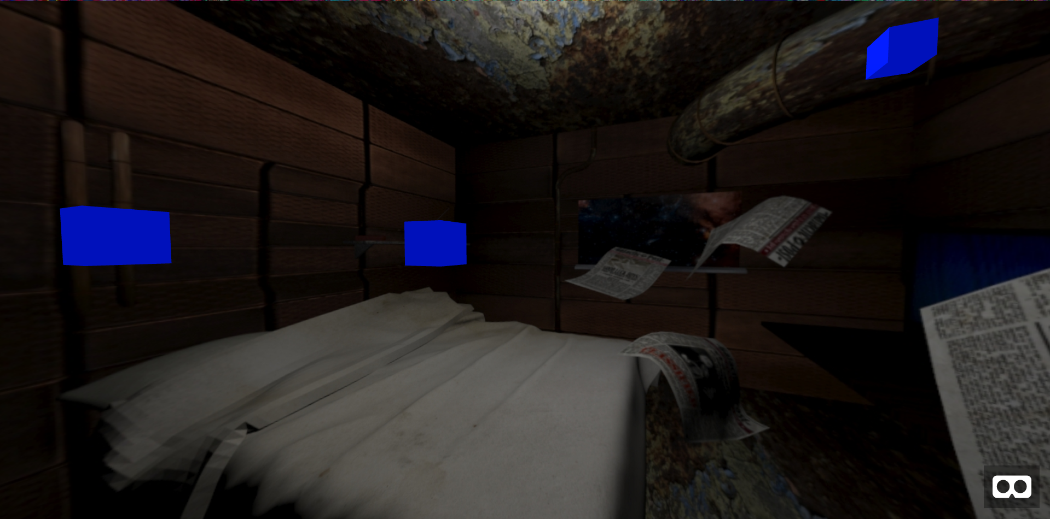

This screenshot shows the beginning of implementing sounds onto the website. The boxes are to represent where the invisible planes are that will be the source for the sounds we use.

The sounds that we have chosen to implement to our scene is a radio channel playing calming music that gets interrupted by a mayday call, dripping water, and some ambient background noise for the ship.

Now that the sounds have been added, the blue blocks have been removed and we have multiple sounds to intrigue the audience and add to the story of what is going on.

Github.io Link:

<https://github.com/ZyaxitronED/Fleetship>

Five Screenshots of Final Prototype:

